**Online Shopping Cart**

**Prerequisite:**

* JDK 1.7+
* Maven 3+

**Stack**

* Java
* JSON Web Token
* Spring Boot
* AngularJS
* Eureka
* Hystrix
* Zuul
* Kafka
* Hazel Cast
* Mongo Db
* MySql

**Projects**

Create the below services (projects) in maven

1. OnlineShoppingCart
2. AuthService
3. CatalogueService
4. CustomerService
5. ShippingService
6. OrderService

**OnlineShoppingCart-UI**

**Project Structure**

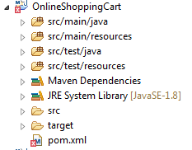

**Pom.xml:**

<project xmlns=*"http://maven.apache.org/POM/4.0.0"* xmlns:xsi=*"http://www.w3.org/2001/XMLSchema-instance"*

xsi:schemaLocation=*"http://maven.apache.org/POM/4.0.0 http://maven.apache.org/xsd/maven-4.0.0.xsd"*>

<modelVersion>4.0.0</modelVersion>

<groupId>com.techm.shoppingcart</groupId>

<artifactId>OnlineShoppingCart</artifactId>

<version>0.0.1-SNAPSHOT</version>

<parent>

<groupId>org.springframework.boot</groupId>

<artifactId>spring-boot-starter-parent</artifactId>

<version>1.4.1.RELEASE</version>

</parent>

<properties>

<project.build.sourceEncoding>UTF-8</project.build.sourceEncoding>

<project.reporting.outputEncoding>UTF-8</project.reporting.outputEncoding>

<java.version>1.8</java.version>

</properties>

<dependencies>

<dependency>

<groupId>org.springframework.boot</groupId>

<artifactId>spring-boot-starter-web</artifactId>

</dependency>

<dependency>

<groupId>org.springframework.boot</groupId>

<artifactId>spring-boot-starter-jersey</artifactId>

</dependency>

<!-- angular dependencies -->

<dependency>

<groupId>org.webjars</groupId>

<artifactId>angularjs</artifactId>

<version>1.4.9</version>

<scope>runtime</scope>

</dependency>

<dependency>

<groupId>io.jsonwebtoken</groupId>

<artifactId>jjwt</artifactId>

<version>0.6.0</version>

</dependency>

<!-- https://mvnrepository.com/artifact/org.json/json -->

<dependency>

<groupId>org.json</groupId>

<artifactId>json</artifactId>

<version>20160810</version>

</dependency>

<dependency>

<groupId>org.webjars</groupId>

<artifactId>bootstrap</artifactId>

<version>3.3.6</version>

<scope>runtime</scope>

</dependency>

</dependencies>

<dependencyManagement>

<dependencies>

<dependency>

<groupId>org.springframework.cloud</groupId>

<artifactId>spring-cloud-dependencies</artifactId>

<version>Brixton.RELEASE</version>

<type>pom</type>

<scope>import</scope>

</dependency>

</dependencies>

</dependencyManagement>

<build>

<plugins>

<plugin>

<groupId>org.springframework.boot</groupId>

<artifactId>spring-boot-maven-plugin</artifactId>

<version>1.2.5.RELEASE</version>

<executions>

<execution>

<goals>

<goal>repackage</goal>

</goals>

</execution>

</executions>

</plugin>

</plugins>

</build>

</project>

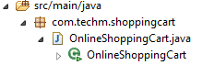

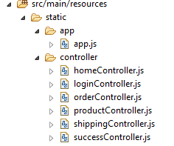

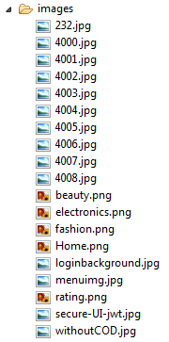

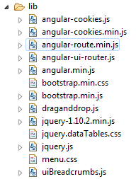



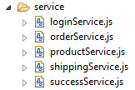

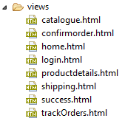

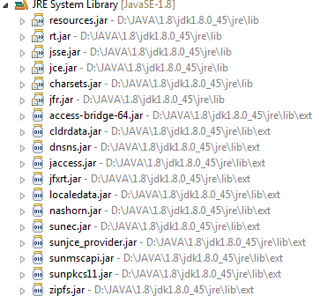

**AuthService**

**Project Structure:**

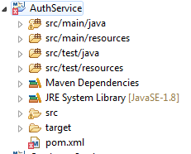

**Pom.xml:**

<project xmlns=*"http://maven.apache.org/POM/4.0.0"* xmlns:xsi=*"http://www.w3.org/2001/XMLSchema-instance"*

xsi:schemaLocation=*"http://maven.apache.org/POM/4.0.0 http://maven.apache.org/xsd/maven-4.0.0.xsd"*>

<modelVersion>4.0.0</modelVersion>

<groupId>AuthService</groupId>

<artifactId>AuthService</artifactId>

<version>0.0.1-SNAPSHOT</version>

<packaging>jar</packaging>

<name>calc Service</name>

<parent>

<groupId>org.springframework.boot</groupId>

<artifactId>spring-boot-starter-parent</artifactId>

<version>1.3.5.RELEASE</version>

</parent>

<properties>

<project.build.sourceEncoding>UTF-8</project.build.sourceEncoding>

<java.version>1.8</java.version>

</properties>

<dependencies>

<dependency>

<groupId>org.springframework.cloud</groupId>

<artifactId>spring-cloud-starter-eureka</artifactId>

</dependency>

<dependency>

<groupId>org.springframework.boot</groupId>

<artifactId>spring-boot-starter-actuator</artifactId>

</dependency>

<dependency>

<groupId>org.springframework.boot</groupId>

<artifactId>spring-boot-starter-web</artifactId>

</dependency>

<dependency>

<groupId>org.springframework.cloud</groupId>

<artifactId>spring-cloud-starter-hystrix</artifactId>

</dependency>

<dependency>

<groupId>org.springframework.cloud</groupId>

<artifactId>spring-cloud-starter-hystrix-dashboard</artifactId>

</dependency>

<!-- angular dependencies -->

<dependency>

<groupId>org.webjars</groupId>

<artifactId>angularjs</artifactId>

<version>1.4.9</version>

<scope>runtime</scope>

</dependency>

<dependency>

<groupId>io.jsonwebtoken</groupId>

<artifactId>jjwt</artifactId>

<version>0.6.0</version>

</dependency>

<!-- https://mvnrepository.com/artifact/org.json/json -->

<dependency>

<groupId>org.json</groupId>

<artifactId>json</artifactId>

<version>20160810</version>

</dependency>

<dependency>

<groupId>org.webjars</groupId>

<artifactId>bootstrap</artifactId>

<version>3.3.6</version>

<scope>runtime</scope>

</dependency>

<dependency>

<groupId>com.hazelcast</groupId>

<artifactId>hazelcast</artifactId>

<version>3.8</version>

</dependency>

<dependency>

<groupId>com.hazelcast</groupId>

<artifactId>hazelcast-client</artifactId>

<version>3.8</version>

</dependency>

</dependencies>

<dependencyManagement>

<dependencies>

<dependency>

<groupId>org.springframework.cloud</groupId>

<artifactId>spring-cloud-dependencies</artifactId>

<version>Brixton.RELEASE</version>

<type>pom</type>

<scope>import</scope>

</dependency>

</dependencies>

</dependencyManagement>

<build>

<plugins>

<plugin>

<groupId>org.springframework.boot</groupId>

<artifactId>spring-boot-maven-plugin</artifactId>

</plugin>

</plugins>

</build>

</project>

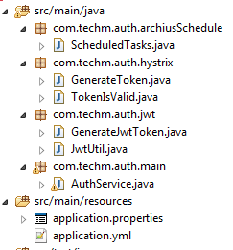

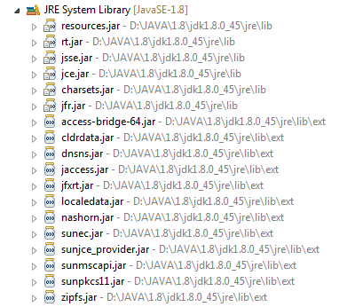



**Catalogue Service**

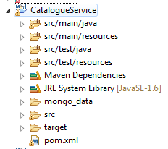

**Pom.xml**

<project xmlns=*"http://maven.apache.org/POM/4.0.0"* xmlns:xsi=*"http://www.w3.org/2001/XMLSchema-instance"*

xsi:schemaLocation=*"http://maven.apache.org/POM/4.0.0 http://maven.apache.org/xsd/maven-4.0.0.xsd"*>

<modelVersion>4.0.0</modelVersion>

<groupId>Catalogue</groupId>

<artifactId>CatalogueService</artifactId>

<version>1.0</version>

<packaging>jar</packaging>

<parent>

<groupId>org.springframework.boot</groupId>

<artifactId>spring-boot-starter-parent</artifactId>

<version>1.4.1.RELEASE</version>

</parent>

<dependencies>

<dependency>

<groupId>org.springframework.cloud</groupId>

<artifactId>spring-cloud-starter-eureka</artifactId>

</dependency>

<dependency>

<groupId>org.springframework.boot</groupId>

<artifactId>spring-boot-starter-actuator</artifactId>

</dependency>

<dependency>

<groupId>org.springframework.boot</groupId>

<artifactId>spring-boot-starter-web</artifactId>

</dependency>

<dependency>

<groupId>org.springframework.cloud</groupId>

<artifactId>spring-cloud-starter-hystrix</artifactId>

</dependency>

<dependency>

<groupId>org.springframework.cloud</groupId>

<artifactId>spring-cloud-starter-hystrix-dashboard</artifactId>

</dependency>

<dependency>

<groupId>org.springframework.boot</groupId>

<artifactId>spring-boot-starter-jersey</artifactId>

</dependency>

<dependency>

<groupId>org.springframework.boot</groupId>

<artifactId>spring-boot-starter-data-mongodb</artifactId>

</dependency>

<dependency>

<groupId>org.springframework.boot</groupId>

<artifactId>spring-boot-starter-data-jpa</artifactId>

</dependency>

<dependency>

<groupId>com.h2database</groupId>

<artifactId>h2</artifactId>

<scope>runtime</scope>

</dependency>

<dependency>

<groupId>org.json</groupId>

<artifactId>json</artifactId>

<version>20090211</version>

</dependency>

<dependency>

<groupId>io.jsonwebtoken</groupId>

<artifactId>jjwt</artifactId>

<version>0.6.0</version>

</dependency>

<dependency>

<groupId>javax.servlet</groupId>

<artifactId>javax.servlet-api</artifactId>

<version>3.1.0</version>

<scope>provided</scope>

</dependency>

</dependencies>

<dependencyManagement>

<dependencies>

<dependency>

<groupId>org.springframework.cloud</groupId>

<artifactId>spring-cloud-dependencies</artifactId>

<version>Brixton.RELEASE</version>

<type>pom</type>

<scope>import</scope>

</dependency>

</dependencies>

</dependencyManagement>

</project>

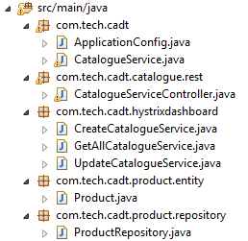

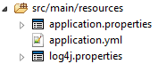

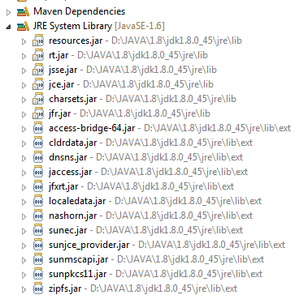





**Customer Service**

**Project Structure:**



**Pom.xml**

<project xmlns=*"http://maven.apache.org/POM/4.0.0"* xmlns:xsi=*"http://www.w3.org/2001/XMLSchema-instance"*

xsi:schemaLocation=*"http://maven.apache.org/POM/4.0.0 http://maven.apache.org/xsd/maven-4.0.0.xsd"*>

<modelVersion>4.0.0</modelVersion>

<groupId>com.techm.customerservice</groupId>

<artifactId>CustomerService</artifactId>

<version>0.0.1-SNAPSHOT</version>

<parent>

<groupId>org.springframework.boot</groupId>

<artifactId>spring-boot-starter-parent</artifactId>

<version>1.4.1.RELEASE</version>

</parent>

<properties>

<project.build.sourceEncoding>UTF-8</project.build.sourceEncoding>

<project.reporting.outputEncoding>UTF-8</project.reporting.outputEncoding>

<java.version>1.8</java.version>

</properties>

<dependencies>

<dependency>

<groupId>org.springframework.boot</groupId>

<artifactId>spring-boot-starter-data-jpa</artifactId>

</dependency>

<dependency>

<groupId>org.springframework.cloud</groupId>

<artifactId>spring-cloud-starter-eureka</artifactId>

</dependency>

<dependency>

<groupId>org.springframework.boot</groupId>

<artifactId>spring-boot-starter-actuator</artifactId>

</dependency>

<dependency>

<groupId>org.springframework.boot</groupId>

<artifactId>spring-boot-starter-web</artifactId>

</dependency>

<dependency>

<groupId>org.springframework.cloud</groupId>

<artifactId>spring-cloud-starter-hystrix</artifactId>

</dependency>

<dependency>

<groupId>org.springframework.cloud</groupId>

<artifactId>spring-cloud-starter-hystrix-dashboard</artifactId>

</dependency>

<dependency>

<groupId>org.springframework.boot</groupId>

<artifactId>spring-boot-starter-jersey</artifactId>

</dependency>

<dependency>

<groupId>javax.servlet</groupId>

<artifactId>javax.servlet-api</artifactId>

<version>3.1.0</version>

<scope>provided</scope>

</dependency>

<dependency>

<groupId>mysql</groupId>

<artifactId>mysql-connector-java</artifactId>

</dependency>

<!-- angular dependencies -->

<dependency>

<groupId>org.webjars</groupId>

<artifactId>angularjs</artifactId>

<version>1.4.9</version>

<scope>runtime</scope>

</dependency>

<dependency>

<groupId>io.jsonwebtoken</groupId>

<artifactId>jjwt</artifactId>

<version>0.6.0</version>

</dependency>

<!-- https://mvnrepository.com/artifact/org.json/json -->

<dependency>

<groupId>org.json</groupId>

<artifactId>json</artifactId>

<version>20160810</version>

</dependency>

<dependency>

<groupId>org.webjars</groupId>

<artifactId>bootstrap</artifactId>

<version>3.3.6</version>

<scope>runtime</scope>

</dependency>

</dependencies>

<dependencyManagement>

<dependencies>

<dependency>

<groupId>org.springframework.cloud</groupId>

<artifactId>spring-cloud-dependencies</artifactId>

<version>Brixton.RELEASE</version>

<type>pom</type>

<scope>import</scope>

</dependency>

</dependencies>

</dependencyManagement>

<build>

<plugins>

<plugin>

<groupId>org.springframework.boot</groupId>

<artifactId>spring-boot-maven-plugin</artifactId>

<version>1.2.5.RELEASE</version>

<executions>

<execution>

<goals>

<goal>repackage</goal>

</goals>

</execution>

</executions>

</plugin>

</plugins>

</build>

</project>

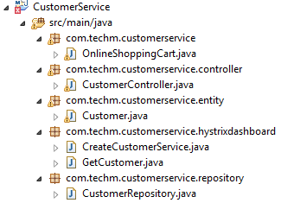

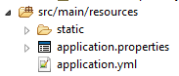

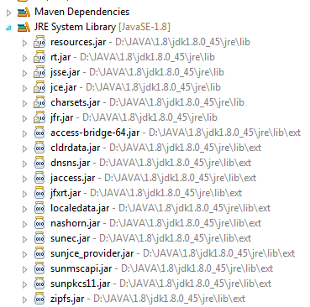



**Order Service**

**Project Structure:**

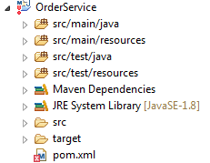

**Pom.xml**

<project xmlns=*"http://maven.apache.org/POM/4.0.0"* xmlns:xsi=*"http://www.w3.org/2001/XMLSchema-instance"* xsi:schemaLocation=*"http://maven.apache.org/POM/4.0.0 http://maven.apache.org/xsd/maven-4.0.0.xsd"*>

<modelVersion>4.0.0</modelVersion>

<groupId>Customer</groupId>

<artifactId>OrderService</artifactId>

<version>1.0</version>

<packaging>jar</packaging>

<parent>

<groupId>org.springframework.boot</groupId>

<artifactId>spring-boot-starter-parent</artifactId>

<version>1.4.0.RELEASE</version>

</parent>

<properties>

<project.build.sourceEncoding>UTF-8</project.build.sourceEncoding>

<project.reporting.outputEncoding>UTF-8</project.reporting.outputEncoding>

<java.version>1.8</java.version>

</properties>

<dependencies>

<dependency>

<groupId>org.springframework.kafka</groupId>

<artifactId>spring-kafka</artifactId>

<version>1.1.2.RELEASE</version>

</dependency>

<dependency>

<groupId>org.springframework.cloud</groupId>

<artifactId>spring-cloud-starter-eureka</artifactId>

</dependency>

<dependency>

<groupId>org.springframework.boot</groupId>

<artifactId>spring-boot-starter-actuator</artifactId>

</dependency>

<dependency>

<groupId>org.springframework.boot</groupId>

<artifactId>spring-boot-starter-web</artifactId>

</dependency>

<dependency>

<groupId>org.springframework.cloud</groupId>

<artifactId>spring-cloud-starter-hystrix</artifactId>

</dependency>

<dependency>

<groupId>org.springframework.cloud</groupId>

<artifactId>spring-cloud-starter-hystrix-dashboard</artifactId>

</dependency>

<dependency>

<groupId>javax.servlet</groupId>

<artifactId>javax.servlet-api</artifactId>

<version>3.1.0</version>

<scope>provided</scope>

</dependency>

<dependency>

<groupId>org.springframework.boot</groupId>

<artifactId>spring-boot-starter-jersey</artifactId>

</dependency>

<dependency>

<groupId>mysql</groupId>

<artifactId>mysql-connector-java</artifactId>

</dependency>

<dependency>

<groupId>org.springframework.boot</groupId>

<artifactId>spring-boot-starter-test</artifactId>

</dependency>

<dependency>

<groupId>io.jsonwebtoken</groupId>

<artifactId>jjwt</artifactId>

<version>0.6.0</version>

</dependency>

<dependency>

<groupId>org.springframework.boot</groupId>

<artifactId>spring-boot-starter-data-jpa</artifactId>

</dependency>

<dependency>

<groupId>com.h2database</groupId>

<artifactId>h2</artifactId>

<scope>runtime</scope>

</dependency>

<dependency>

<groupId>org.json</groupId>

<artifactId>json</artifactId>

<version>20090211</version>

</dependency>

</dependencies>

<dependencyManagement>

<dependencies>

<dependency>

<groupId>org.springframework.cloud</groupId>

<artifactId>spring-cloud-dependencies</artifactId>

<version>Brixton.RELEASE</version>

<type>pom</type>

<scope>import</scope>

</dependency>

</dependencies>

</dependencyManagement>

</project>

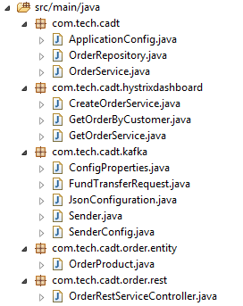



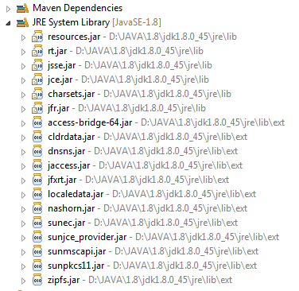



**Shipping Service**

**Project Structure:**

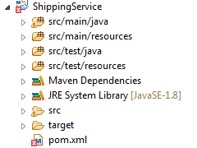

**Pom.xml**

<project xmlns=*"http://maven.apache.org/POM/4.0.0"* xmlns:xsi=*"http://www.w3.org/2001/XMLSchema-instance"* xsi:schemaLocation=*"http://maven.apache.org/POM/4.0.0 http://maven.apache.org/xsd/maven-4.0.0.xsd"*>

<modelVersion>4.0.0</modelVersion>

<groupId>ShippingService</groupId>

<artifactId>ShippingService</artifactId>

<version>1.0</version>

<packaging>jar</packaging>

<parent>

<groupId>org.springframework.boot</groupId>

<artifactId>spring-boot-starter-parent</artifactId>

<version>1.4.0.RELEASE</version>

</parent>

<properties>

<project.build.sourceEncoding>UTF-8</project.build.sourceEncoding>

<project.reporting.outputEncoding>UTF-8</project.reporting.outputEncoding>

<java.version>1.8</java.version>

</properties>

<dependencies>

<dependency>

<groupId>org.springframework.kafka</groupId>

<artifactId>spring-kafka</artifactId>

<version>1.1.2.RELEASE</version>

</dependency>

<dependency>

<groupId>org.springframework.cloud</groupId>

<artifactId>spring-cloud-starter-eureka</artifactId>

</dependency>

<dependency>

<groupId>org.springframework.boot</groupId>

<artifactId>spring-boot-starter-actuator</artifactId>

</dependency>

<dependency>

<groupId>org.springframework.boot</groupId>

<artifactId>spring-boot-starter-web</artifactId>

</dependency>

<dependency>

<groupId>org.springframework.cloud</groupId>

<artifactId>spring-cloud-starter-hystrix</artifactId>

</dependency>

<dependency>

<groupId>org.springframework.cloud</groupId>

<artifactId>spring-cloud-starter-hystrix-dashboard</artifactId>

</dependency>

<dependency>

<groupId>org.springframework.boot</groupId>

<artifactId>spring-boot-starter-jersey</artifactId>

</dependency>

<dependency>

<groupId>org.springframework.boot</groupId>

<artifactId>spring-boot-starter-data-jpa</artifactId>

</dependency>

<dependency>

<groupId>com.h2database</groupId>

<artifactId>h2</artifactId>

<scope>runtime</scope>

</dependency>

<dependency>

<groupId>mysql</groupId>

<artifactId>mysql-connector-java</artifactId>

</dependency>

<dependency>

<groupId>javax.servlet</groupId>

<artifactId>javax.servlet-api</artifactId>

<version>3.1.0</version>

<scope>provided</scope>

</dependency>

<dependency>

<groupId>org.json</groupId>

<artifactId>json</artifactId>

<version>20090211</version>

</dependency>

<dependency>

<groupId>io.jsonwebtoken</groupId>

<artifactId>jjwt</artifactId>

<version>0.6.0</version>

</dependency>

<dependency>

<groupId>javax.servlet</groupId>

<artifactId>javax.servlet-api</artifactId>

<version>3.1.0</version>

<scope>provided</scope>

</dependency>

</dependencies>

<dependencyManagement>

<dependencies>

<dependency>

<groupId>org.springframework.cloud</groupId>

<artifactId>spring-cloud-dependencies</artifactId>

<version>Brixton.RELEASE</version>

<type>pom</type>

<scope>import</scope>

</dependency>

</dependencies>

</dependencyManagement>

</project>

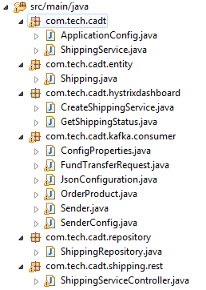



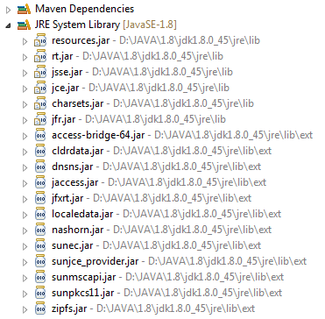



**Eureka server:**

**Project Structure:**

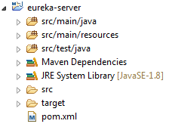

**Pom.xml**

<?xml version=*"1.0"* encoding=*"UTF-8"*?>

<project xmlns=*"http://maven.apache.org/POM/4.0.0"* xmlns:xsi=*"http://www.w3.org/2001/XMLSchema-instance"*

xsi:schemaLocation=*"http://maven.apache.org/POM/4.0.0 http://maven.apache.org/xsd/maven-4.0.0.xsd"*>

<modelVersion>4.0.0</modelVersion>

<groupId>org.exampledriven</groupId>

<artifactId>spring-cloud-eureka-example</artifactId>

<version>0.0.1-SNAPSHOT</version>

<packaging>jar</packaging>

<name>Eureka Server</name>

<description>Eureka Server</description>

<parent>

<groupId>org.springframework.boot</groupId>

<artifactId>spring-boot-starter-parent</artifactId>

<version>1.3.5.RELEASE</version>

</parent>

<properties>

<project.build.sourceEncoding>UTF-8</project.build.sourceEncoding>

<java.version>1.8</java.version>

</properties>

<dependencies>

<dependency>

<groupId>org.springframework.cloud</groupId>

<artifactId>spring-cloud-starter-eureka-server</artifactId>

</dependency>

<dependency>

<groupId>org.springframework.boot</groupId>

<artifactId>spring-boot-starter-actuator</artifactId>

</dependency>

</dependencies>

<dependencyManagement>

<dependencies>

<dependency>

<groupId>org.springframework.cloud</groupId>

<artifactId>spring-cloud-dependencies</artifactId>

<version>Brixton.RELEASE</version>

<type>pom</type>

<scope>import</scope>

</dependency>

</dependencies>

</dependencyManagement>

<build>

<plugins>

<plugin>

<groupId>org.springframework.boot</groupId>

<artifactId>spring-boot-maven-plugin</artifactId>

</plugin>

</plugins>

</build>

</project>

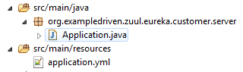

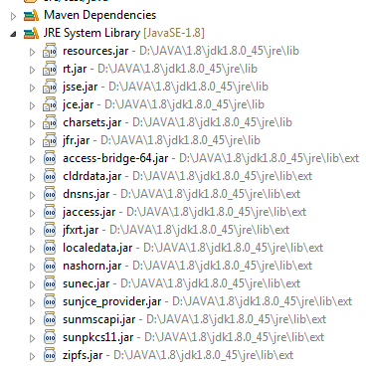



**Hystrix:**

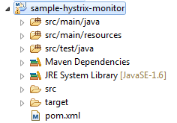

**Pom.xml:**

<?xml version=*"1.0"* encoding=*"UTF-8"*?>

<project xmlns=*"http://maven.apache.org/POM/4.0.0"* xmlns:xsi=*"http://www.w3.org/2001/XMLSchema-instance"*

xsi:schemaLocation=*"http://maven.apache.org/POM/4.0.0 http://maven.apache.org/xsd/maven-4.0.0.xsd"*>

<modelVersion>4.0.0</modelVersion>

<groupId>org.bk</groupId>

<artifactId>hystrix-monitor</artifactId>

<version>1.0.1-SNAPSHOT</version>

<packaging>jar</packaging>

<name>hystrix-monitor</name>

<description>Monitoring Dashboard - Turbine and Hystrix Dashboard</description>

<!--

<parent>

<groupId>org.bk</groupId>

<artifactId>sample-spring-hystrix</artifactId>

<version>1.0.1-SNAPSHOT</version>

<relativePath>../pom.xml</relativePath>

</parent> -->

<parent>

<groupId>org.springframework.boot</groupId>

<artifactId>spring-boot-starter-parent</artifactId>

<version>1.3.5.RELEASE</version>

</parent>

<dependencies>

<dependency>

<groupId>org.springframework.cloud</groupId>

<artifactId>spring-cloud-starter</artifactId>

</dependency>

<dependency>

<groupId>org.springframework.cloud</groupId>

<artifactId>spring-cloud-starter-hystrix-dashboard</artifactId>

</dependency>

<dependency>

<groupId>org.springframework.cloud</groupId>

<artifactId>spring-cloud-starter-turbine</artifactId>

<exclusions>

<exclusion>

<groupId>javax.servlet</groupId>

<artifactId>servlet-api</artifactId>

</exclusion>

</exclusions>

</dependency>

</dependencies>

<dependencyManagement>

<dependencies>

<dependency>

<groupId>org.springframework.cloud</groupId>

<artifactId>spring-cloud-dependencies</artifactId>

<version>Brixton.RELEASE</version>

<type>pom</type>

<scope>import</scope>

</dependency>

</dependencies>

</dependencyManagement>

<build>

<plugins>

<plugin>

<groupId>org.springframework.boot</groupId>

<artifactId>spring-boot-maven-plugin</artifactId>

</plugin>

</plugins>

</build>

</project>

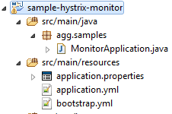

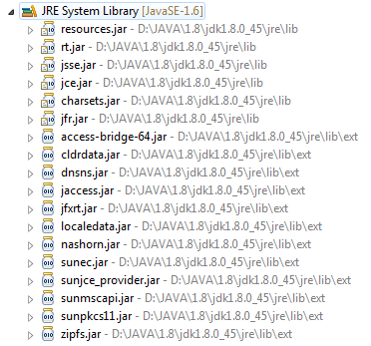



**Zuul server:**

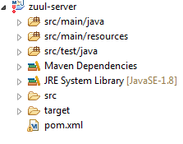

**Pom.xml:**

<?xml version=*"1.0"* encoding=*"UTF-8"*?>

<project xmlns=*"http://maven.apache.org/POM/4.0.0"* xmlns:xsi=*"http://www.w3.org/2001/XMLSchema-instance"*

xsi:schemaLocation=*"http://maven.apache.org/POM/4.0.0 http://maven.apache.org/xsd/maven-4.0.0.xsd"*>

<modelVersion>4.0.0</modelVersion>

<groupId>org.exampledriven</groupId>

<artifactId>zuul-server</artifactId>

<version>0.0.1-SNAPSHOT</version>

<packaging>jar</packaging>

<name>Zuul server</name>

<description>Demo project for Spring Boot</description>

<parent>

<groupId>org.springframework.boot</groupId>

<artifactId>spring-boot-starter-parent</artifactId>

<version>1.3.5.RELEASE</version>

<relativePath/>

</parent>

<properties>

<project.build.sourceEncoding>UTF-8</project.build.sourceEncoding>

<java.version>1.8</java.version>

</properties>

<dependencies>

<dependency>

<groupId>org.springframework.cloud</groupId>

<artifactId>spring-cloud-starter-zuul</artifactId>

</dependency>

<dependency>

<groupId>org.springframework.boot</groupId>

<artifactId>spring-boot-starter-test</artifactId>

<scope>test</scope>

</dependency>

<dependency>

<groupId>org.springframework.boot</groupId>

<artifactId>spring-boot-starter-actuator</artifactId>

</dependency>

<dependency>

<groupId>org.springframework.cloud</groupId>

<artifactId>spring-cloud-starter-eureka</artifactId>

</dependency>

<dependency>

<groupId>org.codehaus.groovy</groupId>

<artifactId>groovy-all</artifactId>

<version>2.4.7</version>

</dependency>

</dependencies>

<dependencyManagement>

<dependencies>

<dependency>

<groupId>org.springframework.cloud</groupId>

<artifactId>spring-cloud-dependencies</artifactId>

<version>Brixton.RELEASE</version>

<type>pom</type>

<scope>import</scope>

</dependency>

</dependencies>

</dependencyManagement>

<build>

<plugins>

<plugin>

<groupId>org.springframework.boot</groupId>

<artifactId>spring-boot-maven-plugin</artifactId>

</plugin>

</plugins>

</build>

</project>

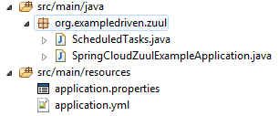

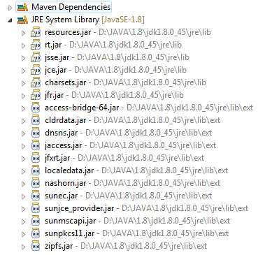



**Reference Architecture with Tech Stack**

